Customer Financial Behavior Analysis for

Mitron Bank

1. *Problem Statement*

Mitron Bank aims to introduce a new line of credit cards to expand its market presence and enhance customer engagement. However, fragmented data and diverse spending patterns across demographics hinder the bank’s ability to understand customer financial behaviors. Providing actionable insights to craft tailored financial solutions is essential to enhance customer satisfaction and propel business growth.

1. *Objective*

This analysis aims to:

* Conduct a thorough analysis of the financial behaviors of 4000 customers across five cities in India, focusing on income distribution, spending habits, savings behaviors, and debt management to generate insights for highly personalized banking solutions.
* Consolidate fragmented data and identify key financial trends, customer pain points, and expenditure behaviors, with a specific emphasis on optimizing the launch of new credit card offerings.
* Develop actionable, data-driven recommendations to refine product offerings, enhance customer segmentation, improve satisfaction, foster loyalty, and drive business growth.

1. *Data Overview*

* Data Source: Customer data directly from the bank.
* Data Volume: 4000 valid customer records, totaling 840000 spending transactions.

Key Metrics

Demographic Information:

* Customer ID, age, city, occupation, gender, marital status, and average income. 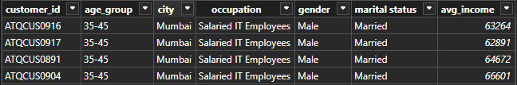

Spending Patterns:

* Monthly spending, spending categories, payment type, and amount.

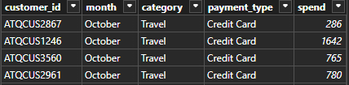

* Segmentation: The data were segmented by age, gender, occupation, and marital status to analyze how different customer groups manage their finances, spending, and savings patterns.
* Analytical Tools: Data was analyzed using Power BI for visualizing trends and identifying key insights.
* Data Quality: 100% of the records were found to be correctly formatted - complete and clean, with no missing data.

1. *Methodology*

4.1 Data Preparation:

* Cleaning: No duplicate records indicating a high level of data integrity.
* Transformation: No inconsistencies were found. One data quality issue was identified and corrected. The city of 'Delhi NCR' was corrected to ''New Delhi ' to ensure data consistency.

4.2  Analytical Methods:

* Descriptive Analysis: Analyzed spending and income patterns to understand overall customer behavior and segmentation. A DAX formula was developed to calculate income utilization, which measured how much income customers were spending relative to their total income. This metric provided insights into customer financial behaviors and helped identify high-utilization segments.
* Segmentation Analysis: Divided customers into segments based on demographics (age, income, spending habits) to tailor product offerings.
* Correlation Analysis: Assessed the relationship between income and spending to identify key factors driving customer financial decisions.
* Trend Analysis: Tracked long-term financial behavior and seasonal spending shifts to anticipate customer needs and predict market trends.
* Comparative Analysis: Compare income and spending patterns across demographics to identify profitable customer segments and optimize product targeting.

1. *Findings:* Key Customer Insights for Targeted Products

5.1 Demographics & Spending Behavior

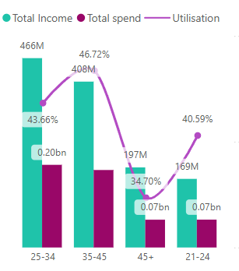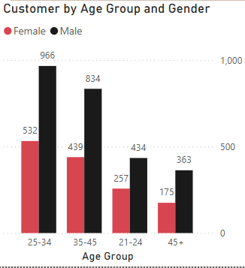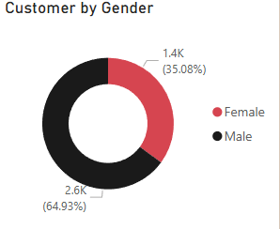Men (64.93%) dominate, showing a preference for technology and electronics, while women (35.07%) prioritize health and wellness. Married individuals spend significantly more ($429M) than single customers ($102M). The 25-34 age group is the largest and exhibits the highest income, spending, and utilization (43.66%), making them prime targets.

5.2 Occupational & Geographic Spending

IT professionals are high earners ($477M) and spenders ($244M), preferring tech-driven financial products (51.04% utilization). Business owners have substantial income ($265M) but lower spending ($88M), suggesting demand for business solutions. Mumbai leads in income and spending (51.43% utilization), signaling demand for premium products.

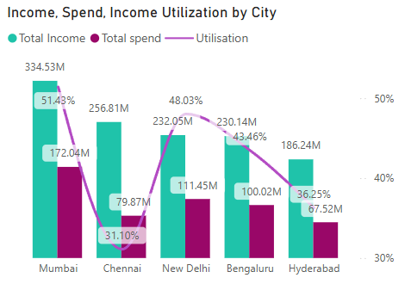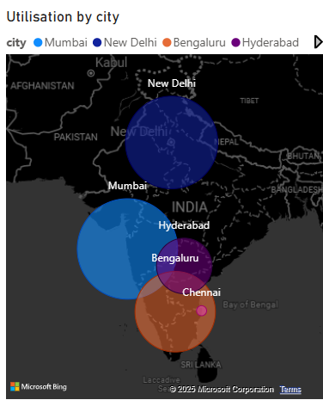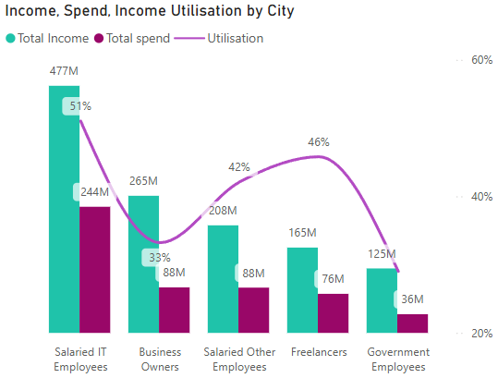

5.3 Spending & Utilization

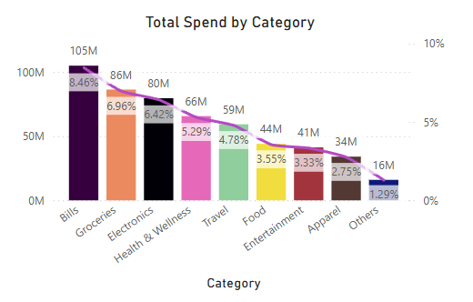Overall utilization is 42.82% ($1.24B income, $531M spent). IT employees lead in spending. Bills ($105M), groceries ($86M), and electronics ($80M) are the top spending categories. Credit card usage within this customer base is notably higher than debit card and UPI transactions, presenting a significant opportunity for the bank to capitalize on this preference.

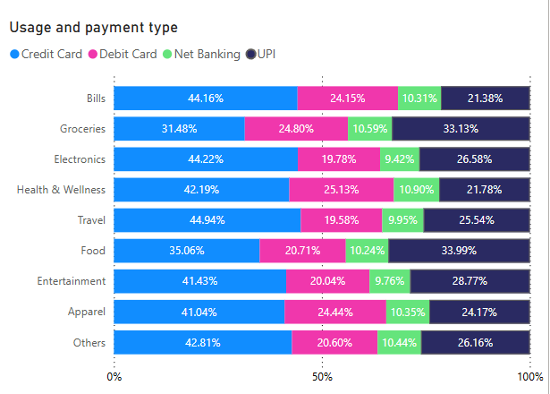

5.4 Targeted Product Opportunities

Younger customers (21-34) prioritize discretionary spending and have higher utilization, making them key targets for lifestyle cards. Married couples spend more on groceries and bills, while single customers focus on lifestyle purchases. These spending patterns inform differentiated product development.

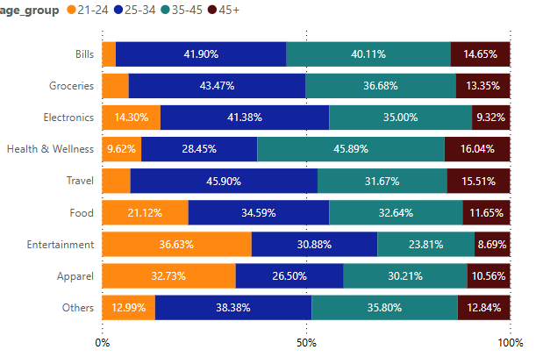

1. *Recommendations*

6.1 Youth & Millennials (21-34)

Prioritize adaptability and immersive experiences. Mitron Bank can captivate this demographic with Lifestyle & Rewards Cards offering lucrative cashback and exclusive incentives on entertainment, dining, and fashion. No-cost EMI options for electronics and travel facilitate high-value purchases while enticing introductory offers—such as waived fees and competitive interest rates—drive swift adoption. Incorporating comprehensive travel insurance and tiered health benefits enhances engagement, while complimentary subscriptions to premium streaming and wellness platforms (Spotify, Amazon Prime, Netflix) add aspirational value. Extended warranties on electronics purchases (given their prevalence in this group), a loyalty points program (2x points on fashion and travel, redeemable for experiences), and free subscriptions to streaming services will further enhance the appeal of these cards.

6.2 Mid-Career Professionals (35-45)

This segment prioritizes exclusivity and financial prosperity. Mitron can cater to their aspirations with Premium Travel & Business Cards offering elite rewards on travel, luxury accommodations, and bespoke concierge services. Additionally, Investment-Linked Credit Options—converting expenditures into mutual funds or high-yield savings—will resonate with this financially astute demographic. Premium cashback on business expenses enhances value, while access to exclusive events and high-profile engagements reinforces prestige.

6.3 High-Net-Worth Individuals & Business Owners

This discerning clientele necessitates both financial agility and strategic control. Mitron can cater to their exacting standards with Exclusive Business Cards based on revenue inflows and interest-free working capital periods, avant-garde expense management tools, and Dynamic Credit Utilization models that adjust based on income fluctuations. AI-driven credit limit assessments will ensure tailored credit solutions for business owners by offering incremental credit limit enhancements. Furthermore, curated alliances with luxury retail partnerships and premium travel rewards such as VIP airport lounge access will be attractive to this segment. Up to 5% cashback on essential business expenses (fuel, dining, office supplies) will further enhance the value proposition.

6.4 Digital Innovation & Sustainability

An AI-driven assistant will help customers monitor spending, optimize budgets, and receive personalized financial advice. This tool will appeal to young professionals and business owners, providing a seamless and informed experience. Introducing a carbon footprint tracker and offering extra rewards for purchases in eco-friendly sectors (organic foods, electric vehicles) will resonate with younger customers who value sustainability.

1. *Conclusion*

Mitron Bank’s hyper-personalized credit cards mark a paradigm shift in customer-centric banking. By combining cutting-edge innovation with deep consumer intelligence, the bank is redefining financial empowerment. The launch of Lifestyle & Rewards Cards, Premium Travel & Business Cards, and Dynamic Credit Solutions goes beyond conventional banking—it anticipates and adapts to evolving needs.

Enhanced with tiered loyalty perks, AI-driven tools, and sustainability rewards, these offerings foster enduring relationships, aligning banking with customer aspirations. Millennials benefit from curated lifestyle rewards, entrepreneurs enjoy flexible credit solutions, and eco-conscious users are incentivized by responsible banking practices, making each financial step a reflection of personal ambition.

With continuous refinement and data-driven foresight, Mitron Bank isn’t merely introducing credit cards—it’s pioneering a new era in personalized banking.